Martha Breternitz was third place winner of the 2007 Three-Dimensional Art Competition
at the River Arts Group 60th Art Show in San Antonio.

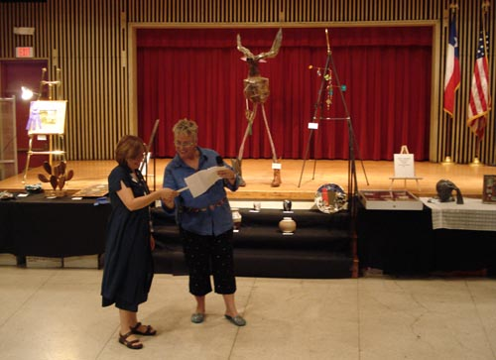

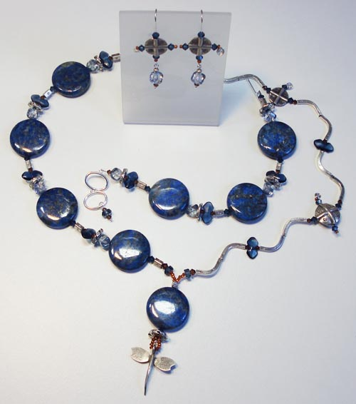
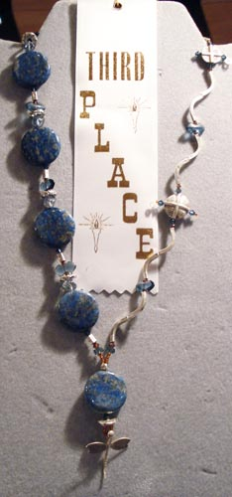
River Arts Group President Janet Paduh giving Martha
her prize.

The winning piece, an asymmetrical dragonfly necklace
made of lapis lazuli, silver, and crystal.
Featured with its matching bracelet and earrings.

Lapis Dragonfly Necklace
3rd Place.

